Student Activity Manager

A Major Project Report Submitted
In partial fulfillment of the requirements for the award of the degree of

Bachelor of Technology
in
Computer Science and Engineering

by

V.Narendra Kumar 19N31A05N7
T.Mahendhar Reddy 19N31A05M2

Under the esteemed guidance of

Dr. S. Shanthi
HOD



Department of Computer Science and Engineering
Malla Reddy College of Engineering & Technology
(Autonomous Institution- UGC, Govt. of India)
(Affiliated to JNTUH, Hyderabad, Approved by AICTE, NBA &NAAC with ‘A’ Grade)
Maisammaguda, Kompally, Dhulapally, Secunderabad – 500100
website: www.mrcet.ac.in

2019-2023

Malla Reddy College of Engineering & Technology
(Autonomous Institution- UGC, Govt. of India)
(Affiliated to JNTUH, Hyderabad, Approved by AICTE, NBA &NAAC with ‘A’ Grade)
Maisammaguda, Kompally, Dhulapally, Secunderabad – 500100
website: www.mrcet.ac.in

CERTIFICATE

This is to certify that this is the bonafide record of the mini project entitled “Student Activity Manager”, submitted by V.Narendra Kumar (19N31A05N7), T.Mahendhar Reddy (19N31A05M2)of B.Tech in the partial fulfillment of the requirements for the degree of Bachelor of Technology in Computer Science and Engineering, Department of CSE during the year 2019-2023. The results embodied in this mini project report have not been submitted to any other university or institute for the award of any degree or diploma.

Internal Guide Head of the Department
Dr. S. Shanthi Dr. S. Shanthi
HOD Professor

External Examiner

DECLARATION

We hereby declare that the project titled “Student Activity Manager” submitted to Malla Reddy College of Engineering and Technology (UGC Autonomous), affiliated to Jawaharlal Nehru Technological University Hyderabad (JNTUH) for the award of the degree of Bachelor of Technology in Computer Science and Engineering is a result of original research carried-out in this thesis. It is further declared that the project report or any part thereof has not been previously submitted to any University or Institute for the award of degree.

V.Narendra Kumar 19N31A05N7

T .Mahendhar Reddy 19N31A05M2

ACKNOWLEDGEMENT

We feel ourselves honored and privileged to place our warm salutation to our college Malla Reddy College of Engineering and Technology (UGC-Autonomous) and our Principal
Dr.Srinivas rao sir who gave us the opportunity to have experience in engineering and profound technical knowledge.

We express our heartiest thanks to our Head of the Department Dr. S.Shanthi Mam for encouraging us in every aspect of our project and helping us realize our full potential.
We would like to thank our internal guide Dr. S.Shanthi Mam, HOD and Project Coordinator----------, for their regular guidance and constant encouragement. We are extremely grateful to her valuable suggestions and unflinching co-operation throughout project work.
We would like to thank our Class Incharge Chandusha mam who in spite of being busy with his duties took time to guide and keep us on the correct path.
We would also like to thank all the supporting staff of the Department of CSE and all other departments who have been helpful directly or indirectly in making our project a success.
We are extremely grateful to our parents for their blessings and prayers for the completion of our project that gave us strength to do our project.

With regards and gratitude,

V.Narendra Kumar 19N31A05N7

T .Mahendhar Reddy 19N31A05M2

ABSTRACT

- Students Activity Manager is an Management Software which is useful in Educational Institutions. This Application Consists of two Main features. First one is that Managing the late Coming students on day to day basis..Second feature of this application is to manage the fee details of a students. Educational institutions are facing issues with the permission slips at the time of exams regarding fee dues.So in order to avoid this issues when the students pay the fees will upload the receipt in this application.This Application will help the Educational institutions To avoid paper works on this issues and institutions can easily manage the Students Activity.

TABLE OF CONTENTS

S.NO | TITLE | PG.NO
INTRODUCTION | 01
PURPOSE AND OBJECTIVES | 02
EXISTING AND PROPOSED SYSTEM 03
SCOPE OF PROJECT 03
LITERATURE SURVEY | 04
SYSTEM ANALYSIS | 05

LIST OF FIGURES

FIGURE.NO | NAME | PG.NO
3.1.2 | ARCHITECTURE | 15
3.2.1 | WHAT CAN PYTHON TECHNOLOGY DO? | 18
3.2.4 | SQL LITE: | 19
4.3.2.1 | CLASS DIAGRAM | 29
4.3.2.2 | USE CASE DIAGRAM | 29
4.3.2.3 | SEQUENCE DIAGRAMS | 31
4.3.2.4 | DATA FLOW DIAGRAM | 31
4.3.2.5 | STATE CHART DIAGRAMS | 32
4.3.2.6 | COMPONENT DIAGRAM | 34

1. INTRODUCTION
This chapter gives an overview about the purpose, aim, objectives, background and operation environment of the system.

  - PURPOSE, AIM AND OBJECTIVES:

Resume is the first meeting between you and aprospective employer more often now than ever. So, how doyou want to be remembered ? Wrinkled and unorganized. Neatand structured. Long and boring. Precise and interesting.Companies do not have the time to interview every applicantthat is interested in the job. If they did, there would not be acompany to work for. They use an eliminating process. That'sright - resumes.When a job seeker wants to apply for a job online thengenerally he/she needs to attach his/her resume with the email.Online Resume Building System provides the users thepopular resume formats & a better way to show their resumesto the employers. A job seeker does not need to attach aresume with every email, he/she just have to include the URL of his/her resume and the employer can view the resume onlineby clicking on the link and can download as well.

1.2 BACKGROUND OF PROJECT:

Resume is the first meeting between you and aprospective employer more often now than ever. So, how doyou want to be remembered ? Wrinkled and unorganized. Neatand structured. Long and boring. Precise and interesting.Companies do not have the time to interview every applicantthat is interested in the job. If they did, there would not be acompany to work for. They use an eliminating process. That'sright - resumes.When a job seeker wants to apply for a job online thengenerally he/she needs to attach his/her resume with the email.Online Resume Building System provides the users thepopular resume formats & a better way to show their resumesto the employers. A job seeker does not need to attach aresume with every email, he/she just have to include the URL of his/her resume and the employer can view the resume onlineby clicking on the link and can download as well.

1.3 SCOPE OF PROJECT:

As we all know Resume is one of the Important thing in the interview process. creating resume manually is bit difficult task but our projects makes it simpler even if you want to generate many resume’s with a single click.

1.4 MODULES DESCRIPTION:

This project is composed of 2 main modules which also include sub modules:
1.First module contains a form through which user can fill in the deatails and selete a template and generate the template.

It provides the users thepopular resume formats & a better way to show their resumesto the employers.

A job seeker does not need to attach aresume with every email, he/she just have to include the URL of his/her resume and the employer can view the resume onlineby clicking on the link and can download as well.

2. In Second Module This project will help you through the process that can be followed to build your resume-builder using Django in python.

Implementing the project will give you the satisfaction of auto-generating it on your own and helping working professionals with the same .

Build a Resume-Builder Web App and add it to your resume to get recognized

With additional Features like generating large ‘N’ of resumes, Which is a useful feature for a Collages or Organisations

2. SYSTEM ANALYSIS
In this chapter, we will discuss and analyze about the developing process of Audit Control including software requirement specification (SRS) and comparison between existing and proposed system. The functional and non-functional requirements are included in SRS part to provide complete description and overview of system requirement before the developing process is carried out. Besides that, existing vs. proposed provides a view of how the proposed system will be more efficient than the existing one.

2.1 HARDWARE AND SOFTWARE REQUIREMENTS

2.1.1 HARDWARE REQUIREMENTS:

Processor : Intel or AMD.
Ram : 1 GB or above.
Hard disk : 40GB or above.

2.1.2 SOFTWARE REQUIREMENTS:

Technology/Language : Django/Python
Data Base : SQLite.
Operating System : Windows, Linux, Mac.
IDE : VS Code

2.2 SOFTWARE REQUIREMENT SPECIFICATION:

2.2.1 SRS:

Software Requirement Specification (SRS) is the starting point of the software developing activity. As system grew more complex it became evident that the goal of the entire system cannot be easily comprehended. Hence the need for the requirement phase arose. The software project is initiated by the client needs. The SRS is the means of translating the ideas of the minds of clients (the input) into a formal document (the output of the requirement phase.)
The SRS phase consists of two basic activities:

- Problem/Requirement Analysis:
The process is order and more nebulous of the two, deals with understand the problem, the goal and constraints.
- Requirement Specification:
Here, the focus is on specifying what has been found giving analysis such as representation, specification languages and tools, and checking the specifications are addressed during this activity.
The Requirement phase terminates with the production of the validate SRS document. Producing the SRS document is the basic goal of this phase.

2.2.2 ROLE OF SRS:

The purpose of the Software Requirement Specification is to reduce the communication gap between the clients and the developers. Software Requirement Specification is the medium through which the client and user needs are accurately specified. It forms the basis of software development. A good SRS should satisfy all the parties involved in the system.

2.2.3 SCOPE:

This document is the only one that describes the requirements of the system. It is meant for the use by the developers, and will also be the basis for validating the final delivered system. Any changes made to the requirements in the future will have to go through a formal change approval process. The developer is responsible for asking for clarifications, where necessary, and will not make any alterations without the permission of the client.

2.2.4 EXISTING SYSTEM:

The Format which is designed is manual. But creating different resume formats is not easy. To reduce the burden we have developed this software.The different processes involved are:
To maintain the details like personal, educational &skills.

To maintain the three default resume formats.Select appropriate one and display the data in required formatAlso generating multiple resume’s at a time is not possibleInstead we have to generate them one by oneThe existing system of the resume builder is prepared in the MS-Word Application software.

The Format which is designed is manual. But creating different resume formats is not easy. To reduce the burden we have developed this software. The different processes involved are:

To maintain the details like personal, educational &skills.
To maintain the three default resume formats.
Select appropriate one and display the data in required format.

2.2.4.1 DRAWBACKS OF EXISTING SYSTEM:

The existing system has lot of problems such as
-To generate multiple resume’s there is no easy way we have to do one by one
-There is no database to store and retrieve the details from MS-Word
-Time delay is more becausewe haveto prepare the resume manually

2.2.5 PROPOSED SYSTEM:

- Our project will contain 2 parts
- First one will be same as existing system(Used to Generate a single resume)
- Second part will be useful for generating multiple resume’s while the data is uploaded in an excel sheet.
- As this Feature is not available anywhere on the internet.

Advantages of proposed system

To generate multiple resume’s with a single all we have to do is upload an excel file with all the data required
-There will be database to store and retrieve the details
-we can generate thousands of resumes with in a fraction of seconds
.

3. TECHNOLOGIES USED

3.1 Django :
Django is a high-level Python web framework that enables rapid development of secure and maintainable websites. Built by experienced developers, Django takes care of much of the hassle of web development, so you can focus on writing your app without needing to reinvent the wheel. It is free and open source, has a thriving and active community, great documentation, and many options for free and paid-for support.
Django helps you write software that is:
Complete
Django follows the "Batteries included" philosophy and provides almost everything developers might want to do "out of the box". Because everything you need is part of the one "product", it all works seamlessly together, follows consistent design principles, and has extensive and up-to-date documentation.
Versatile
Django can be (and has been) used to build almost any type of website — from content management systems and wikis, through to social networks and news sites. It can work with any client-side framework, and can deliver content in almost any format (including HTML, RSS feeds, JSON, XML, etc).
Internally, while it provides choices for almost any functionality you might want (e.g. several popular databases, templating engines, etc.), it can also be extended to use other components if needed.

- URLs: While it is possible to process requests from every single URL via a single function, it is much more maintainable to write a separate view function to handle each resource. A URL mapper is used to redirect HTTP requests to the appropriate view based on the request URL. The URL mapper can also match particular patterns of strings or digits that appear in a URL and pass these to a view function as data.
- View: A view is a request handler function, which receives HTTP requests and returns HTTP responses. Views access the data needed to satisfy requests via models, and delegate the formatting of the response to templates.
- Models: Models are Python objects that define the structure of an application's data, and provide mechanisms to manage (add, modify, delete) and query records in the database.
- Templates: A template is a text file defining the structure or layout of a file (such as an HTML page), with placeholders used to represent actual content. A view can dynamically create an HTML page using an HTML template, populating it with data from a model. A template can be used to define the structure of any type of file; it doesn't have to be HTML!
3.1.1 THEORY AND HISTORY:
Django was design and developed by Lawrence journal world in 2003 and publicly released under BSD license in July 2005. Currently, DSF (Django Software Foundation) maintains its development and release cycle.
Django was released on 21, July 2005. Its current stable version is 2.2.5 which was released April 1, 2019.
The latest official version is 2.2.5 (LTS). Read the 2.2.5 release notes, then install it with pip:
pip install Django==2.2.5
As part of the Django 3.0 development process, Django 3.0a1 is available. This release is only for users who want to try the new version and help identify remaining bugs before the 3.0 release. Please read the 3.0 release notes before using this package.
Install the alpha with pip:
pip install --pre Django

3.1.2 ARCHITECTURE:

Django is based on MVT (Model-View-Template) architecture. MVT is a software design pattern for developing a web application. MVT Structure has the following three parts –
Model: The model is going to act as the interface of your data. It is responsible for maintaining data. It is the logical data structure behind the entire application and is represented by a database (generally relational databases such as MySql, Postgres). To check more, visit – Django Models View: The View is the user interface — what you see in

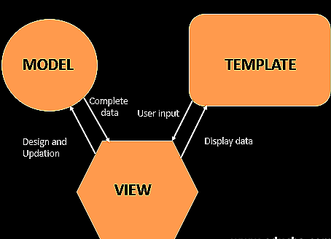

Project Structure :
A Django Project when initialized contains basic files by default such as manage.py, view.py, etc. A simple project structure is enough to create a single-page application. Here are the major files and their explanations. Inside the geeks_site folder ( project folder ) there will be the following files-

manage.py- This file is used to interact with your project via the command line(start the server, sync the database… etc). For getting the full list of commands that can be executed by manage.py type this code in the command window-
$ python manage.py help
folder ( geeks_site ) – This folder contains all the packages of your project. Initially, it contains four files –

- _init_.py – It is a python package. It is invoked when the package or a module in the package is imported. We usually use this to execute package initialization code, for example for the initialization of package-level data.
- settings.py – As the name indicates it contains all the website settings. In this file, we register any applications we create, the location of our static files, database configuration details, etc.
- urls.py – In this file, we store all links of the project and functions to call.
- wsgi.py – This file is used in deploying the project in WSGI. It is used to help your Django application communicate with the webserver.

3.2 PYTHON:

Python is a computer programming language often used to build websites and software, automate tasks, and conduct data analysis. Python is a general-purpose language, meaning it can be used to create a variety of different programs and isn’t specialized for any specific problems. This versatility, along with its beginner-friendliness, has made it one of the most-used programming languages today. A survey conducted by industry analyst firm RedMonk found that it was the second-most popular programming language among developers in 2021 [1].
Did you know? The name Python comes from Monty Python. When Guido van Rossum was creating Python, he was also reading the scripts from BBC’s Monty Python’s Flying Circus. He thought the name Python was appropriately short and slightly mysterious.
Python is commonly used for developing websites and software, task automation, data analysis, and data visualization. Since it’s relatively easy to learn, Python has been adopted by many non-programmers such as accountants and scientists, for a variety of everyday tasks, like organizing finances.
“Writing programs is a very creative and rewarding activity,” says University of Michigan and Coursera instructor Charles R Severance in his book Python for Everybody. “You can write programs for many reasons, ranging from making your living to solving a difficult data analysis problem to having fun to helping someone else solve a problem.”
What can you do with python? Some things include:
- Data analysis and machine learning
- Web development
- Automation or scripting
- Software testing and prototyping
- Everyday tasks
Here’s a closer look at some of these common ways Python is used.
If you’re new to Python (and programming in general), you can begin writing your first Python program in minutes by taking from the University of Michigan.

Data analysis and machine learning
Python has become a staple in data science, allowing and other professionals to use the language to conduct complex statistical calculations, create data visualizations, build machine learning algorithms, manipulate and analyze data, and complete other data-related tasks.
Python can build a wide range of different data visualizations, like line and bar graphs, pie charts, histograms, and 3D plots. Python also has a number of libraries that enable coders to

Software testing and prototyping
In software development, Python can aid in tasks like build control, bug tracking, and testing. With Python, software developers can automate testing for new products or features. Some Python tools used for software testing include Green and Requestium.

Everyday tasks
Python isn't only for programmers and data scientists. Learning Python can open new possibilities for those in less data-heavy professions, like journalists, small business owners, or social media marketers. Python can also enable non-programmer to simplify certain tasks in their lives. Here are just a few of the tasks you could automate with Python:
- Keep track of stock market or crypto prices
- Send yourself a text reminder to carry an umbrella anytime it’s raining
- Update your grocery shopping list
- Renaming large batches of files
- Converting text files to spreadsheets
- Randomly assign chores to family members
- Fill out online forms automatically

Why is Python so popular?
Python is popular for a number of reasons. Here’s a deeper look at what makes it so versatile and easy to use for coders.
- It has a simple syntax that mimics natural language, so it’s easier to read and understand. This makes it quicker to build projects, and faster to improve on them.
- It’s versatile. Python can be used for many different tasks, from web development to machine learning.
- It’s beginner friendly, making it popular for entry-level coders.
- It’s open source, which means it’s free to use and distribute, even for commercial purposes.
- Python’s archive of modules and libraries—bundles of code that third-party users have created to expand Python’s capabilities—is vast and growing.
Additionally, you can get a headstart with the rich selection of frameworks and libraries. They will save you the hassle of coding features by hand, accelerating your time-to-market. (Check out the most popular Python web frameworks and scientific libraries in the sections below.)
But wait—isn’t Python slow? You’ve probably heard the rumor somewhere.
While it’s true that Python’s runtime is slower compared to other languages, Python is still the language of choice for companies such as Google. Why?
The limiting factor is your employee’s time.
You want to optimize your most expensive resources—and developer hours don’t come cheap. So you need all the help you can get to shorten time-to-market, even if it leads to slower runtime execution.
But that’s not all. For situations where performance really does matter, Python offers tried and tested solutions to incorporate other, faster languages into the code—like Cython, for example.
3. Reading Python code is intuitive, making maintenance a breeze
Python’s syntax is clear and concise. The language is designed to be readable and close to actual English, making it easy to decipher. Python also requires fewer lines of code to achieve results compared to languages such as C or Java.
The simplicity of Python helps greatly when you have to read the code you’ve written or code from another developer. Code review goes much faster when you have fewer lines of code to actually review, and the code reads like English. There’s also less “catch-up” involved when the code changes hands—you can figure out pretty quickly what each function is supposed to do.
With code that’s easier to understand and navigate, you can reduce the amount of work needed to maintain and expand your code base.
4. Python gives you tried and tested scalability
No one can really predict when your user numbers will start surging and scalability will become a priority. This is why it’s a good idea to use a language that scales great and, as we’ve mentioned above, is easy to maintain.
Some of the most ambitious projects around the web—YouTube, Reddit, EVE Online—all use Python to serve their user base reliably.
Takeaways
Why Python, then? There are a few reasons:
you will write your code faster, optimizing developer resources;
you will have access to tons of dedicated Python libraries and frameworks, so you won’t have to build everything from scratch;
you will review your code more easily with a simple and clear language;
and much more!
If you really need to find the one language to rule them all, the choice is clear.

3.2.3 HOW WILL PYTHON TECHNOLOGY CHANGE MY LIFE?
Now, there is no secret that Python is one of the most commonly used programming languages. For the past few years, Python has held the number one position as the “Most Popular Coding Language.”

Python is an interpreted high-level programming language for general-purpose programming. It has a design philosophy that emphasizes code readability, notably using significant whitespace. It provides constructs that enable clear programming on both small and large scales.

Python features a dynamic type system and automatic memory management. It supports multiple programming paradigms, including object-oriented, imperative, functional and procedural, and has a large and comprehensive standard library. Python interpreters are available for many operating systems. CPython, the reference implementation of Python, is open source software and has a community-based development model, as do nearly all of Python's other implementations. Python and CPython are managed by the non-profit Python Software Foundation.
This language was Created by Guido van Rossum. Though it was first released in 1991, it actually conceived in the late 1980s. After three decades, his invention has overtaken almost all of its rivals and brought coding to the fingertips of people who were once baffled by it. In the past 12 months, most programmers have searched for Python on Google. The number of queries has trebled since 2010, while those for other major programming languages have been flat or declining.

In July 2018, Van Rossum stepped down as the leader in the language community after 30 years.

The language has two main advantages - its simplicity and flexibility. Its straightforward syntax and use of indented spaces make it easy to learn, read and share. Its avid practitioners, known as Pythonistas, have uploaded 145,000 custom-built software packages to an online repository. These cover everything from game development to astronomy and can be installed and inserted into a Python program in a matter of seconds. This versatility means that the Central Intelligence Agency has used it for hacking, Google for crawling web pages, Pixar for producing movies and Spotify for recommending songs. Some of the most popular packages harness “machine learning”, by crunching large quantities of data to pick out patterns that would otherwise be imperceptible.

Supports of Python
Python also offers many choices for web development. Frameworks such as Django and Pyramid. Micro-frameworks such as Flask and Bottle. Advanced content management systems such as Plone and Django CMS.

Python's standard library supports many Internet protocols: HTML and XML, JSON, Email processing. Support for FTP, IMAP, and other Internet protocols. Easy-to-use socket interface.

And the Package Index has yet more libraries. Such as - Requests (a powerful HTTP client library), BeautifulSoup (an HTML parser that can handle all sorts of oddball HTML), Feedparser for parsing RSS/Atom feeds, Paramiko (implementing the SSH2 protocol), Twisted Python (a framework for asynchronous network programming).

3.2.4 SQL LITE:

SQLite is a software library that implements a self-contained, serverless, zero-configuration, transactional SQL database engine. SQLite is one of the fastest-growing database engines around, but that's growth in terms of popularity, not anything to do with its size. The source code for SQLite is in the public domain.

What is SQLite?
SQLite is an in-process library that implements a self-contained, serverless, zero-configuration, transactional SQL database engine. It is a database, which is zero-configured, which means like other databases you do not need to configure it in your system.

SQLite engine is not a standalone process like other databases, you can link it statically or dynamically as per your requirement with your application. SQLite accesses its storage files directly.

Why SQLite?
SQLite does not require a separate server process or system to operate (serverless).
SQLite comes with zero-configuration, which means no setup or administration needed.
A complete SQLite database is stored in a single cross-platform disk file.
SQLite is very small and light weight, less than 400KiB fully configured or less than 250KiB with optional features omitted.SQLite is self-contained, which means no external dependencies.
SQLite transactions are fully ACID-compliant, allowing safe access from multiple processes or threads.SQLite supports most of the query language features found in SQL92 (SQL2) standard.
SQLite is written in ANSI-C and provides simple and easy-to-use API.
SQLite is available on UNIX (Linux, Mac OS-X, Android, iOS) and Windows (Win32, WinCE, WinRT).
SQLite A Brief History
2000 - D. Richard Hipp designed SQLite for the purpose of no administration required for operating a program.
2000 - In August, SQLite 1.0 released with GNU Database Manager.

2011 - Hipp announced to add UNQl interface to SQLite DB and to develop UNQLite (Document oriented database).

4. SYSTEM DESIGN & UML DIAGRAMS

System design is transition from a user oriented document to programmers or data base personnel. The design is a solution, how to approach to the creation of a new system. This is composed of several steps. It provides the understanding and procedural details necessary for implementing the system recommended in the feasibility study. Designing goes through logical and physical stages of development, logical design reviews the present physical system, prepare input and output specification, details of implementation plan and prepare a logical design walkthrough.

4.1 SOFTWARE DESIGN:

In designing the software following principles are followed:
- Modularity and partitioning: Software is designed such that, each system should consists of hierarchy of modules and serve to partition into separate function.
- Coupling: Modules should have little dependence on other modules of a system.
- Cohesion: Modules should carry out in a single processing function.
- Shared use: Avoid duplication by allowing a single module be called by other that need the function it provides.

4.2 ARCHITECTURE:

Architecture diagram is a diagram of a system, in which the principal parts or functions are represented by blocks connected by lines that show the relationships of the blocks. The block diagram is typically used for a higher level, less detailed description aimed more at understanding the overall concepts and less at understanding the details of implementation.

.

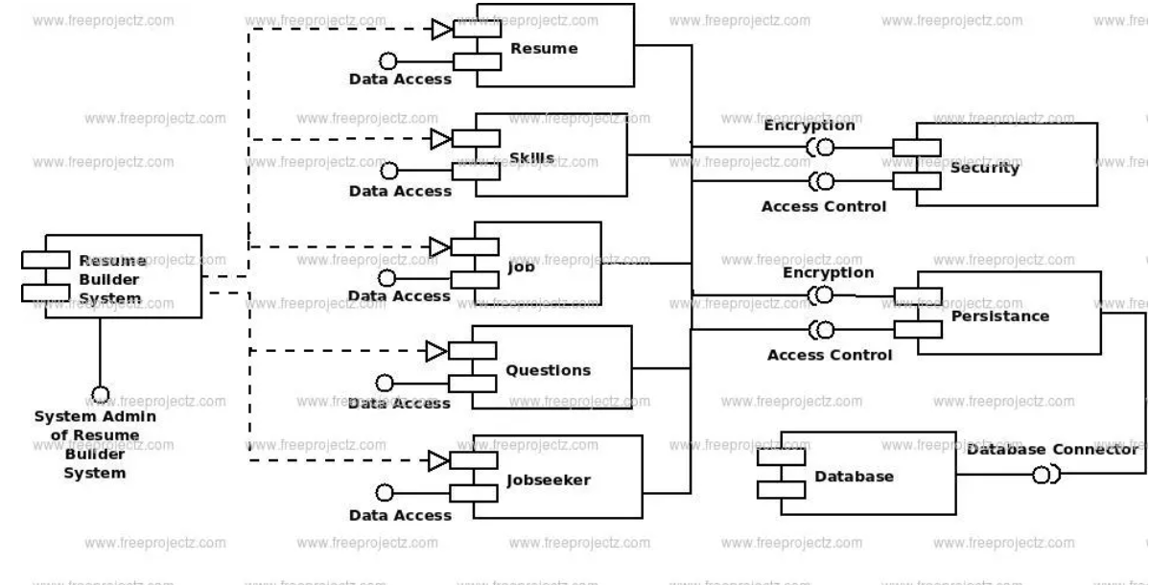

FIGURE 4.2: SYSTEM FLOW DIAGRAM

4.3 UNIFIED MODELING LANGUAGE (UML) :

The unified modeling is a standard language for specifying, visualizing, constructing and documenting the system and its components is a graphical language which provides a vocabulary and set of semantics and rules. The UML focuses on the conceptual and physical representation of the system. It captures the decisions and understandings about systems that must be constructed. It is used to understand, design, configure and control information about the systems.
Depending on the development culture, some of these artifacts are treated more or less formally than others. Such artifacts are not only the deliverables of a project; they are also critical in controlling, measuring, and communicating about a system during its development and after its deployment.
The UML addresses the documentation of a system's architecture and all of its details. The UML also provides a language for expressing requirements and for tests. Finally, the UML provides a language for modeling the activities of project planning and release management.
4.3.1 BUILDING BLOCKS OF UML:

The vocabulary of the UML encompasses three kinds of building blocks:
- Things.
- Relationships.
- Diagrams.
4.3.1.1 Things in the UML:

Things are the abstractions that are first-class citizens in a model; relationships tie these things together; diagrams group interesting collections of things.
There are four kinds of things in the UML:
- Structural things.
- Behavioral things.
- Grouping things.
- Annotational things.
- Structural things are the nouns of UML models. The structural things used in the project design are:
- First, a class is a description of a set of objects that share the same attributes, operations, relationships and semantics.
Window
origin
size
open()
close()
move()
display()

Fig: Classes
- Second, a use case is a description of set of sequence of actions that a system performs that yields an observable result of value to particular actor.
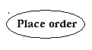
Fig: Use Cases
- Third, a node is a physical element that exists at runtime and represents a computational resource, generally having at least some memory and often processing capability.
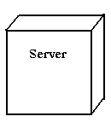
Fig: Nodes
- Behavioral things are the dynamic parts of UML models. The behavioral thing used is:
- Interaction: An interaction is a behavior that comprises a set of messages exchanged among a set of objects within a particular context to accomplish a specific purpose. An interaction involves a number of other elements, including messages, action sequences (the behavior invoked by a message, and links (the connection between objects).
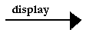
Fig: Messages

4.3.1.2 Relationships in the UML:
There are four kinds of relationships in the UML:
- Dependency.
- Association.
- Generalization.
- Realization.

- A dependency is a semantic relationship between two things in which a change to one thing may affect the semantics of the other thing (the dependent thing).
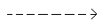
Fig: Dependencies
- An association is a structural relationship that describes a set links, a link being a connection among objects. Aggregation is a special kind of association, representing a structural relationship between a whole and its parts.
Fig: Association
- A generalization is a specialization/ generalization relationship in which objects of thespecialized element (the child) are substitutable for objects of the generalized element(the parent).
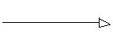
Fig: Generalization
- A realization is a semantic relationship between classifiers, where in one classifier specifies a contract that another classifier guarantees to carry out.
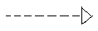
Fig: Realization

    - UML DIAGRAMS:

4.3.2.1 CLASS DIAGRAM:
A class is a representation of an object and, in many ways; it is simply a template from which objects are created. Classes form the main building blocks of an object-oriented application. Although thousands of students attend the university, you would only model one class, called Student, which would represent the represent the entire collection of students.

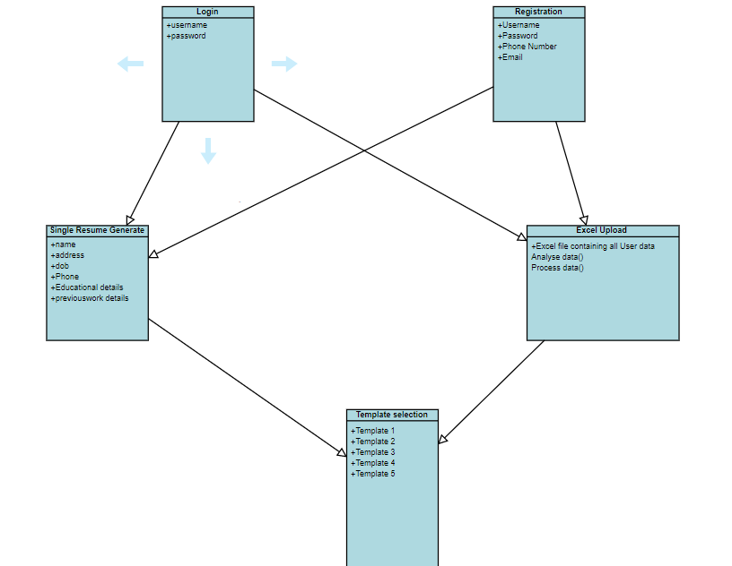
FIGURE 4.3.2.1: CLASS DIAGRAM

4.3.2.2 USE CASE DIAGRAM:

A use case diagram is a graph of actors set of use cases enclosed by a system boundary, communication associations between the actors and users and generalization among use cases. The use case model defines the outside (actors) and inside (use case) of the system’s behavior.

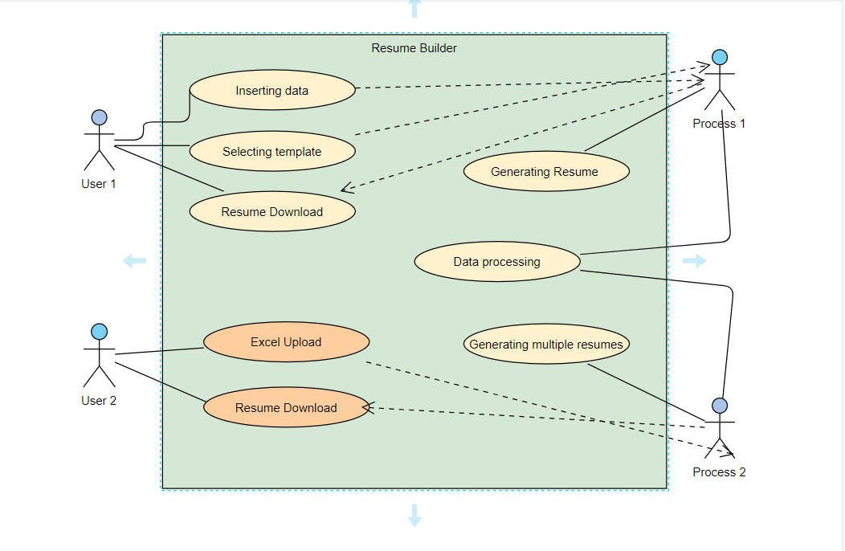

FIGURE 4.3.2.2: USE CASE DIAGRAM

4.3.2.3 SEQUENCE DIAGRAM:

Sequence diagram are used to represent the flow of messages, events and actions between the objects or components of a system. Time is represented in the vertical direction showing the sequence of interactions of the header elements, which are displayed horizontally at the top of the diagram.

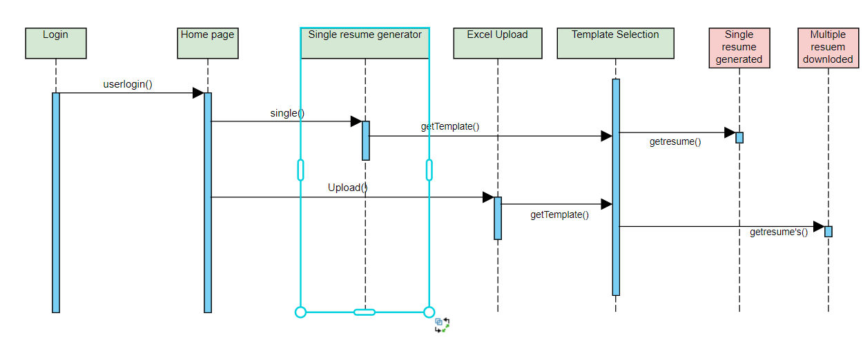
FIGURE 4.3.2.3: SEQUENCE DIAGRAM

4.3.2.4 Data Flow DIAGRAM:

A data-flow diagram is a way of representing a flow of data through a process or a system (usually an information system). The DFD also provides information about the outputs and inputs of each entity and the process itself. A data-flow diagram has no contrflow —

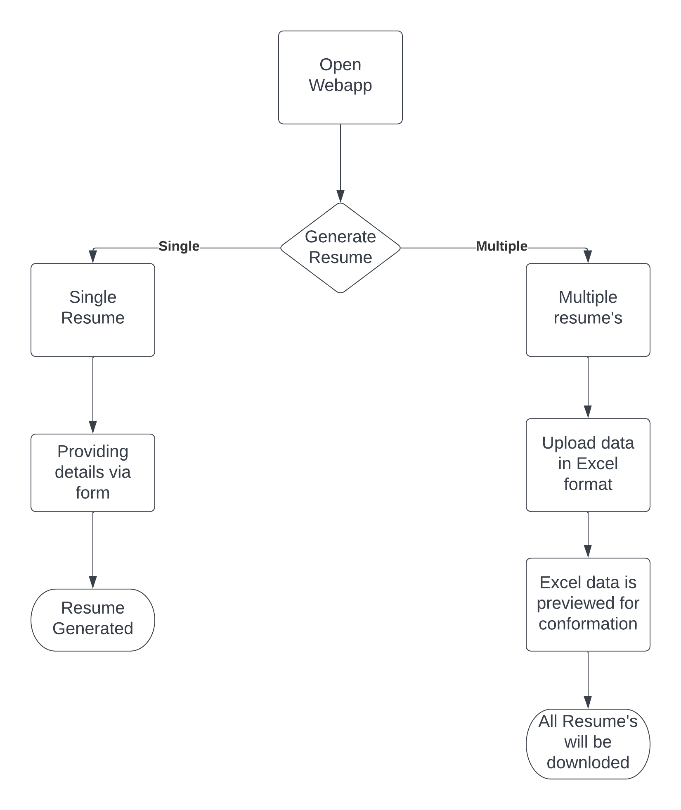
FIGURE 4.3.2.4:
4.3.2.5 STATE CHART DIAGRAM:
State chart diagram is used to describe the states of different objects in its life cycle. So the emphasis is given on the state changes upon some internal or external events. These states of objects are important to analyse and implement them accurately. State chart diagrams are very important for describing the states. States can be identified as the condition of objects when a particular event occurs.

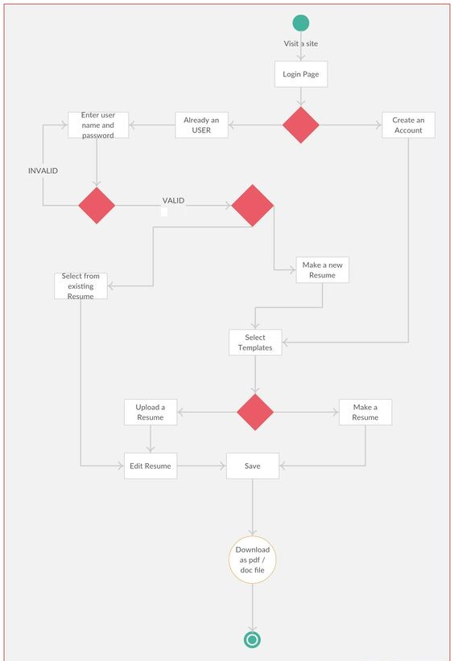
FIGURE 4.3.2.5: STATE CHART

S
4.3.2.6 COMPONENT DIAGRAM:

In the Unified Modeling Language, a Component diagram depicts how components are wired together to form larger components and or software systems. They are used to illustrate the structure of arbitrarily complex systems.

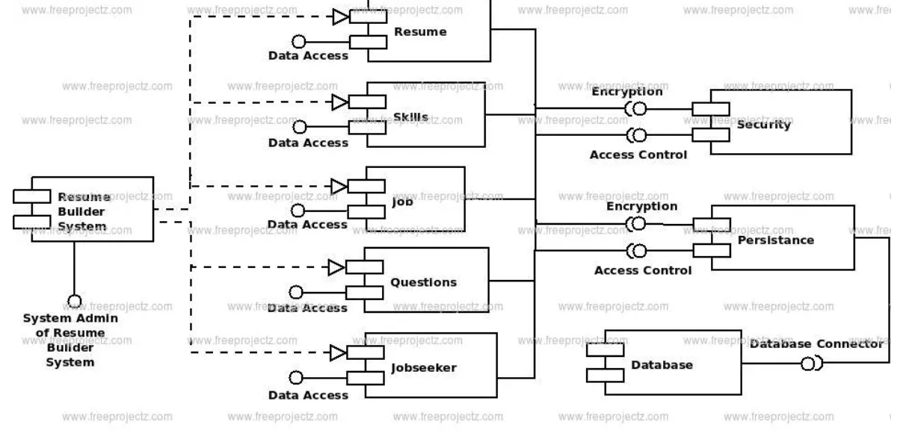

5. INPUT/OUTPUT DESIGN

5.1 INPUT DESIGN:

Input Design plays a vital role in the life cycle of software development, it requires very careful attention of developers. The input design is to feed data to the application as accurate as possible. So inputs are supposed to be designed effectively so that the errors occurring while feeding are minimized. According to Software Engineering Concepts, the input forms or screens are designed to provide to have a validation control over the input limit, range and other related validations.Input design is the process of converting the user created input into a computer-based format. The goal of the input design is to make the data entry logical and free from errors.

Validations are required for each data entered. Whenever a user enters an erroneous data, error message is displayed and the user can move on to the subsequent pages after completing all the entries in the current page.

5.2 OUTPUT DESIGN:

The Output from the computer is required to mainly create an efficient method of communication within the company primarily among the project leader and his team members, in other words, the administrator and the clients. The output of VPN is the system which allows the project leader to manage his clients in terms of creating new clients and assigning new projects to them, maintaining a record of the project validity and providing folder level access to each client on the user side depending on the projects allotted to him. After completion of a project, a new project may be assigned to the client. User authentication procedures are maintained at the initial stages itself.

6. IMPLEMENTATION
6.1urls.PY File:

from django.urls import path,include
from . import views
from . import admin

urlpatterns = [
path('',views.login,name='login'),
path('logout',views.logout,name='logout'),

path('index',views.index,name='index'),

path('home',views.home,name='home'),
path('retrive',views.retrive,name='retrive'),
path('func',views.func),

path('analyize',views.analyize,name='analyize'),
]

6.2 Views.py:

count=0

from django.http import HttpResponse
from django.shortcuts import render
from django.views.decorators.csrf import csrf_exempt
from tablib import Dataset
import pandas as pd

from io import BytesIO
from django.template.loader import get_template
import xhtml2pdf.pisa as pisa
from django.conf import settings
from django.template import Context
from io import BytesIO
import jinja2
# Create your views here.

@csrf_exempt
def savepdf(template_path,data={}):
template_loader = jinja2.FileSystemLoader(settings.BASE_DIR)
template_env = jinja2.Environment(loader=template_loader)
template=template_env.get_template(template_path)
html=template.render({"context":data})
result=BytesIO()
filename="%s_Resume.pdf"%(data['roll'])

try:
with open(str(settings.BASE_DIR)+f'/static/{filename}.pdf','wb+') as output:
pdf=pisa.pisaDocument(BytesIO(html.encode("UTF-8")),output)
except Exception as e:
print(e)
# if(not pdf.err):
# return HttpResponse(result.getvalue(),content_type="application/pdf")
# return None
@csrf_exempt
def index(request):
return render(request,'index.html')
# pdf = render_to_pdf('template2.html', params)
@csrf_exempt
def upload(request):
if request.method == 'POST':
t=2
dataset = Dataset()
template=request.POST.get('temp')
new_persons = request.FILES['myfile']
df=pd.read_csv(new_persons)

temp1=request.POST.get("temp1")
temp2=request.POST.get("temp2")
temp3=request.POST.get("temp3")
temp4=request.POST.get("temp4")
temp5=request.POST.get("temp5")
print(temp1,"\n",temp2,"\n",temp3,"\n",temp4,"\n",temp5,"\n",)
# imported_data = dataset.load(new_persons.read(),format='xlsx')
list1=[]
# count=0
for i in range(0,df.shape[0]):
dict1={}
temp=[]
company=[]
projects=[]

projects_name=list(df['projects_name'][i].split(','))
project_desc=list(df['projects_description'][i].split('$'))
print(project_desc)
for j in range(0,len(project_desc)):
temp={'n':projects_name[j],'d':project_desc[j]}
projects.append(temp)

_10th=list(df['10th'][i].split(','))
intermediate=list(df['intermediate'][i].split(','))
graduation=list(df['graduation'][i].split(','))

company_nam=list(df['company_name'][i].split(','))
company_duration=list(df['company_duration'][i].split(','))
company_title=list(df['company_title'][i].split(','))
company_city=list(df['company_city'][i].split(','))

skills=list(df['skills'][i].split(','))
hobbies=list(df['hobbies'][i].split(','))
company1={
"n":company_nam[0],
'c':company_city[0],
't':company_title[0],
'y':company_duration[0],
}
company2={
"n":company_nam[1],
'c':company_city[1],
't':company_title[1],
'y':company_duration[1],
}
company=[company1,company2]
# for j in range(0,len(company_city)):
# temp={'n':company_nam[j],'d':company_duration[j],'t':company_title[j],'c':company_city[j]}
# company.append(temp)
school1=[_10th[0],intermediate[0],graduation[0]]
school2=[_10th[1],intermediate[1],graduation[1]]
school3=[_10th[2],intermediate[2],graduation[2]]

school1={
"n":_10th[0],
'a':_10th[1],
'g':_10th[2],
}
school2={
"n":intermediate[0],
'a':intermediate[1],
'g':intermediate[2],
}
school3={
"n":graduation[0],
'a':graduation[1],
'g':graduation[2],
}
school=[school1,school2,school3]
dict1={
'T':t,
'roll':df['roll_No'][i],
'Name':df['name'][i],
'Role':df['current_role'][i],
'Mob':df['phone_no'][i],
'Email':df['email'][i],
'Address':df['Address'][i],
'Projects':projects,
"school1":school1,
"school2":school2,
"school3":school3,

'company':company,
'Skills':skills,
'Hobbies':hobbies
}
# print(dict1)
savepdf('templates/old/test.html', dict1)
# if pdf:
# response=HttpResponse(pdf,content_type="application/pdf")
# filename="%s_Resume.pdf"%(dict1['roll'])
# content="inline;filename='%s'"%(filename)
# content="attachment;filename=%s"%(filename)
# response['content-Disposition']=content
# return response
list1.append(dict1)
# print(df['10th'][i])
# print("AAAAAAAAAAAAAAAA")
context={
'list1':list1
}
# for i in context:
if(temp1=="True"):
# pdfkit.from_file(('template2.html',{"context":context}), 'out.pdf')
return render(request,'form.html')

# return render(request,"template1.html",{"context":context})
elif(temp2=="True"):
return render(request,'upload.html')

# return render(request,"template2.html",{"context":context})
else:
return render(request,'upload.html')
return render(request,'upload.html')
@csrf_exempt
def form(request):
if(request.method=='POST'):
t=1
name=request.POST.get("name")
role=request.POST.get("role")
email=request.POST.get("email")
mob=request.POST.get("mob")
Address=request.POST.get("Address")
Experience=request.POST.get("Experience")
sn1=request.POST.get("1school")
sa1=request.POST.get("1add")
sg1=request.POST.get("1gpa")
sn2=request.POST.get("2school")
sa2=request.POST.get("2add")
sg2=request.POST.get("2gpa")
sn3=request.POST.get("3school")
sa3=request.POST.get("3add")
sg3=request.POST.get("3gpa")
cn1=request.POST.get("1company")
ct1=request.POST.get("1title")
cy1=request.POST.get("1years")
cc1=request.POST.get("1city")
cn2=request.POST.get("2company")
ct2=request.POST.get("2title")
cy2=request.POST.get("2years")
cc2=request.POST.get("1city")
h=request.POST.get("hobbies")
s=request.POST.get("skills")
hobbies=list(h.split(","))
skills=list(s.split(","))
temp1=request.POST.get("temp1")
temp2=request.POST.get("temp2")
temp3=request.POST.get("temp3")
temp4=request.POST.get("temp4")
temp5=request.POST.get("temp5")

print(s)
print(skills)
school1={
"n":sn1,
'a':sa1,
'g':sg1,
}
school2={
"n":sn2,
'a':sa2,
'g':sg2,
}
school3={
"n":sn3,
'a':sa3,
'g':sg3,
}
company1={
"n":cn1,
'c':cc1,
't':ct1,
'y':cy1,
}
company2={
"n":cn2,
'c':cc2,
't':ct2,
'y':cy2,
}
school=[school1,school2,school3]
company=[company1,company2]
list1=[]
dict1={
"T":t,
"Name":name,
"Role":role,
"Email":email,
"Mob":mob,
"Address":Address,
"Experience":Experience,
"school":school,
"company":company,

"Hobbies":hobbies,
"Skills":skills,
}
list1=[dict1]
# list2.append(dict1)
# print(df['10th'][i])
# print("AAAAAAAAAAAAAAAA")
context={
'list1':list1
}
print(context)
print(temp1,"\n",temp2,"\n",temp3,"\n",temp4,"\n",temp5,"\n",)
if(temp1=="True"):

return render(request,"template1.html",{"context":context})
elif(temp2=="True"):
return render(request,"template2.html",{"context":context})
else:
return render(request,'form.html')
return render(request,'form.html')

6.3 settings.py:

BASE_DIR = Path(__file__).resolve().parent.parent

SECRET_KEY = 'django-insecure-_u1ma^@_x0sz$6%oejj9-d_1_wy1w1lvd7vpu9$a&2$ws3)vfm'

DEBUG = True

ALLOWED_HOSTS = []

INSTALLED_APPS = [
'django.contrib.admin',
'django.contrib.auth',
'django.contrib.contenttypes',
'django.contrib.sessions',
'django.contrib.messages',
'django.contrib.staticfiles',
'Builder',
]

MIDDLEWARE = [
'django.middleware.security.SecurityMiddleware',
'django.contrib.sessions.middleware.SessionMiddleware',
'django.middleware.common.CommonMiddleware',
'django.middleware.csrf.CsrfViewMiddleware',
'django.contrib.auth.middleware.AuthenticationMiddleware',
'django.contrib.messages.middleware.MessageMiddleware',
'django.middleware.clickjacking.XFrameOptionsMiddleware',
]

ROOT_URLCONF = 'ResumeBuilder.urls'

TEMPLATES = [
{
'BACKEND': 'django.template.backends.django.DjangoTemplates',
'DIRS': ['templates'],
'APP_DIRS': True,
'OPTIONS': {
'context_processors': [
'django.template.context_processors.debug',
'django.template.context_processors.request',
'django.contrib.auth.context_processors.auth',
'django.contrib.messages.context_processors.messages',
],
},
},
]

WSGI_APPLICATION = 'ResumeBuilder.wsgi.application'

DATABASES = {
'default': {
'ENGINE': 'django.db.backends.sqlite3',
'NAME': BASE_DIR / 'db.sqlite3',
}
}

AUTH_PASSWORD_VALIDATORS = [
{
'NAME': 'django.contrib.auth.password_validation.UserAttributeSimilarityValidator',
},
{
'NAME': 'django.contrib.auth.password_validation.MinimumLengthValidator',
},
{
'NAME': 'django.contrib.auth.password_validation.CommonPasswordValidator',
},
{
'NAME': 'django.contrib.auth.password_validation.NumericPasswordValidator',
},
]

LANGUAGE_CODE = 'en-us'

TIME_ZONE = 'UTC'

USE_I18N = True

USE_TZ = True
STATIC_URL = '/static/'
import os

7. TESTING
Software testing is a critical element of software quality assurance and represents the ultimate review of specification, design and code generation.
7.1 TESTING OBJECTIVES:

- To ensure that during operation the system will perform as per specification.
- To make sure that system meets the user requirements during operation
- To make sure that during the operation, incorrect input, processing and output will be detected
- To see that when correct inputs are fed to the system the outputs are correct
- To verify that the controls incorporated in the same system as intended
- Testing is a process of executing a program with the intent of finding an error
- A good test case is one that has a high probability of finding an as yet undiscovered error

The software developed has been tested successfully using the following testing strategies and any errors that are encountered are corrected and again the part of the program or the procedure or function is put to testing until all the errors are removed. A successful test is one that uncovers an as yet undiscovered error.

Note that the result of the system testing will prove that the system is working correctly. It will give confidence to system designer, users of the system, prevent frustration during implementation process etc.

7.2 TESTING METHODOLOGIES:
- White box testing.
- Black box testing.
- Unit testing.
- Integration testing.
- User acceptance testing.
- Output testing.
- Validation testing.
- System testing.
- White Box Testing:

White box testing is a testing case design method that uses the control structure of the procedure design to derive test cases. All independents path in a module are exercised at least once, all logical decisions are exercised at once, execute all loops at boundaries and within their operational bounds exercise internal data structure to ensure their validity. Here the customer is given three chances to enter a valid choice out of the given menu. After which the control exits the current menu.

- Black Box Testing:

Black Box Testing attempts to find errors in following areas or categories, incorrect or missing functions, interface error, errors in data structures, performance error and initialization and termination error. Here all the input data must match the data type to become a valid entry.

- Unit Testing:

Unit testing focuses verification effort on the smallest unit of Software design that is the module. Unit testing exercises specific paths in a module’s control structure to ensure complete coverage and maximum error detection. This test focuses on each module individually, ensuring that it functions properly as a unit. Hence, the naming is Unit Testing.

- Integration Testing:

Integration testing addresses the issues associated with the dual problems of verification and program construction. After the software has been integrated a set of high order tests are conducted. The main objective in this testing process is to take unit tested modules and builds a program structure that has been dictated by design.

The following are the types of Integration Testing:

- Top Down Integration:

This method is an incremental approach to the construction of program structure. Modules are integrated by moving downward through the control hierarchy, beginning with the main program module.
- Bottom Up Integration:

This method begins the construction and testing with the modules at the lowest level in the program structure. Since the modules are integrated from the bottom up, processing required for modules subordinate to a given level is always available and the need for stubs is eliminated.

- User acceptance Testing:

User Acceptance of a system is the key factor for the success of any system. The system under consideration is tested for user acceptance by constantly keeping in touch with the prospective system users at the time of developing and making changes wherever required. The system developed provides a friendly user interface that can easily be understood even by a person who is new to the system.

- Output Testing:

After performing the validation testing, the next step is output testing of the proposed system, since no system could be useful if it does not produce the required output in the specified format. Asking the users about the format required by them tests the outputs generated or displayed by the system under consideration. Hence the output format is considered in 2 ways – one is on screen and another in printed format.

- Validation Testing:

Validation testing is generally performed on the following fields:

- Text Field:
The text field can contain only the number of characters lesser than or equal to its size. The text fields are alphanumeric in some tables and alphabetic in other tables. Incorrect entry always flashes and error message.

\
- Numeric Field:
The numeric field can contain only numbers from 0 to 9. An entry of any character flashes an error messages. The individual modules are checked for accuracy and what it has to perform.

- Preparation of Test Data:

Taking various kinds of test data does the above testing. Preparation of test data plays a vital role in the system testing. After preparing the test data the system under study is tested using that test data. While testing the system by using test data errors are again uncovered and corrected by using above testing steps and corrections are also noted for future use.

- Using Live Test Data:

Live test data are those that are actually extracted from organization files. After a system is partially constructed, programmers or analysts often ask users to key in a set of data from their normal activities. Then, the systems person uses this data as a way to partially test the system. In other instances, programmers or analysts extract a set of live data from the files and have them entered themselves.

- Using Artificial Test Data:

Artificial test data are created solely for test purposes, since they can be generated to test all combinations of formats and values. In other words, the artificial data, which can quickly be prepared by a data generating utility program in the information systems department, make possible the testing of all login and control paths through the program.

The most effective test programs use artificial test data generated by persons other than those who wrote the programs. Often, an independent team of testers formulates a testing plan, using the systems specifications.

7.3 USER TRAINING:

Whenever a new system is developed, user training is required to educate them about the working of the system so that it can be put to efficient use by those for whom the system has been primarily designed. For this purpose the normal working of the project was demonstrated to the prospective users. Its working is easily understandable and since the expected users are people who have good knowledge of computers, the use of this system is very easy.

7.4 MAINTAINENCE:

This covers a wide range of activities including correcting code and design errors. To reduce the need for maintenance in the long run, we have more accurately defined the user’s requirements during the process of system development. Depending on the requirements, this system has been developed to satisfy the needs to the largest possible extent. With development in technology, it may be possible to add many more features based on the requirements in future. The coding and designing is simple and easy to understand which will make maintenance easier.

7.5 TESTING STRATEGY :

A strategy for system testing integrates system test cases and design techniques into a well planned series of steps that results in the successful construction of software. The testing strategy must co-operate test planning, test case design, test execution, and the resultant data collection and evaluation .A strategy for software testing must accommodate low-level tests that are necessary to verify that a small source code segment has been correctly implemented as well as high level tests that validate major system functions against user requirements.
Software testing is a critical element of software quality assurance and represents the ultimate review of specification design and coding.

7.5.1 SYSTEM TESTING:

Software once validated must be combined with other system elements (e.g. Hardware, people, database). System testing verifies that all the elements are proper and that overall system function performance is achieved. It also tests to find discrepancies between the system and its original objective, current specifications and system documentation.
7.5.2 UNIT TESTING:

In unit testing different are modules are tested against the specifications produced during the design for the modules. Unit testing is essential for verification of the code produced during the coding phase, and hence the goals to test the internal logic of the modules. Using the detailed design description as a guide, important Conrail paths are tested to uncover errors within the boundary of the modules. This testing is carried out during the programming stage itself. In this type of testing step, each module was found to be working satisfactorily as regards to the expected output from the module. In Due Course, latest technology advancements will be taken into consideration. As part of technical build-up many components of the networking system will be generic in nature so that future projects can either use or interact with this.

7.6 TEST CASES:

INPUT FORM
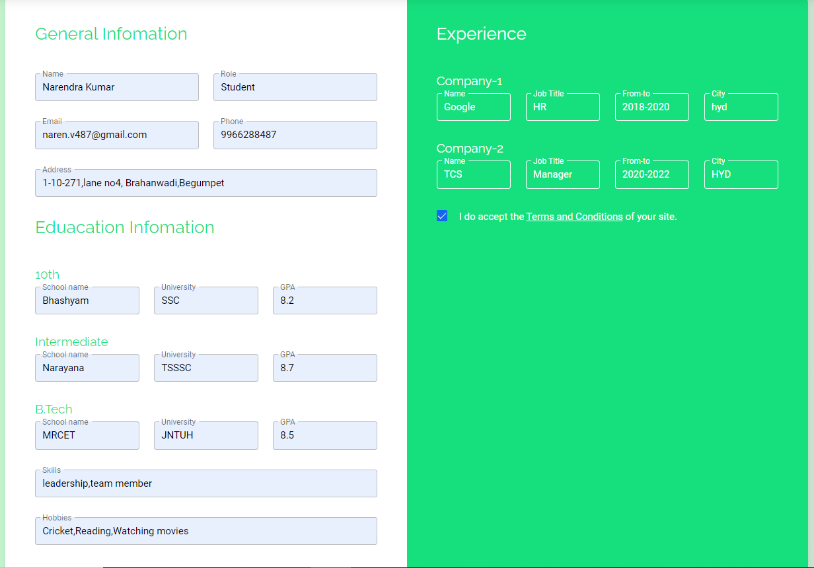

OUTPUT:

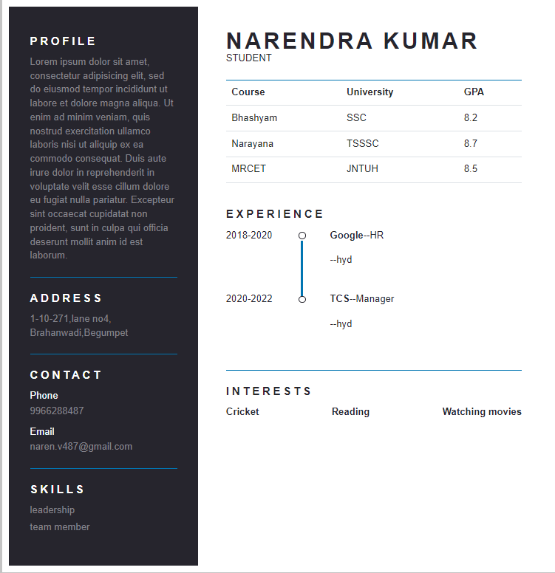
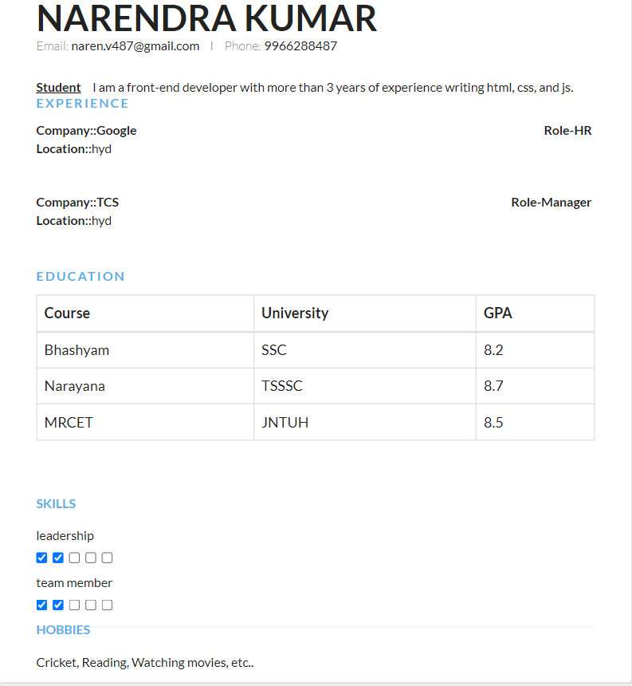

Input for excel upload
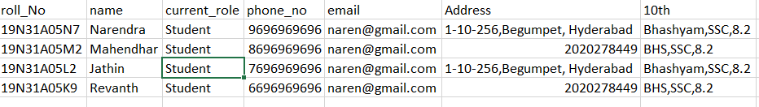
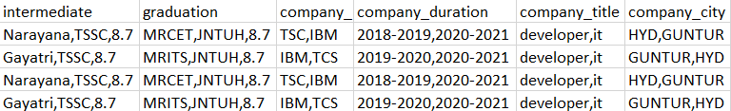

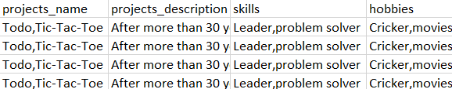

Output files
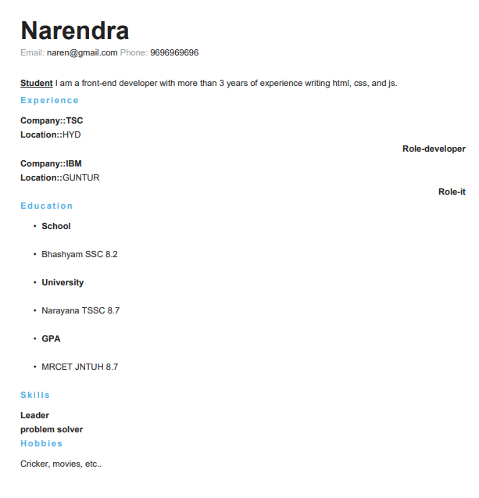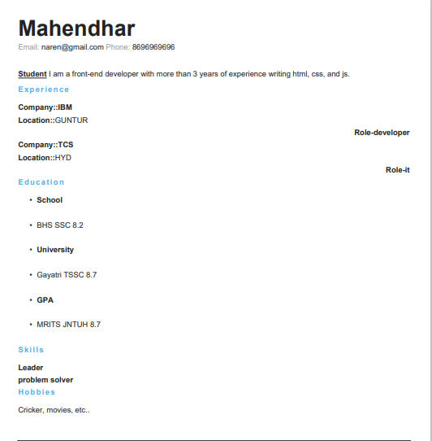

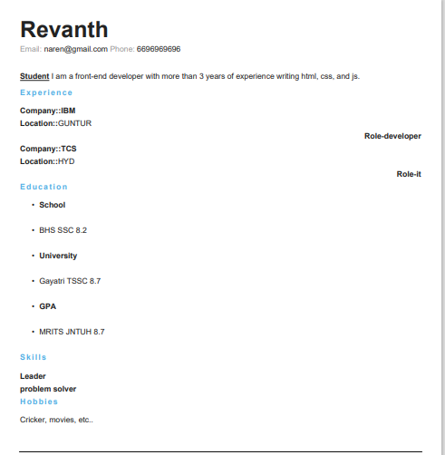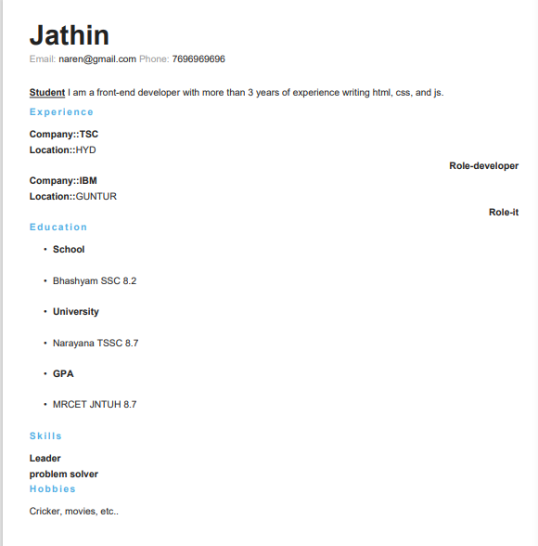

8. OUTPUT SCREENS
8.1 Home screen
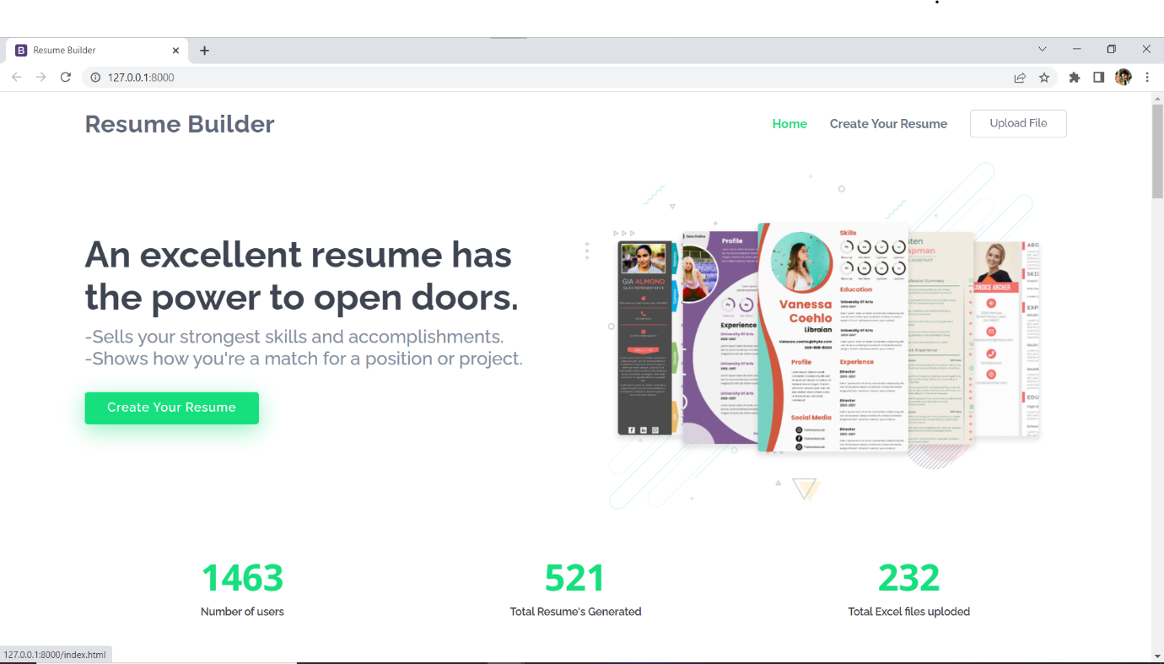
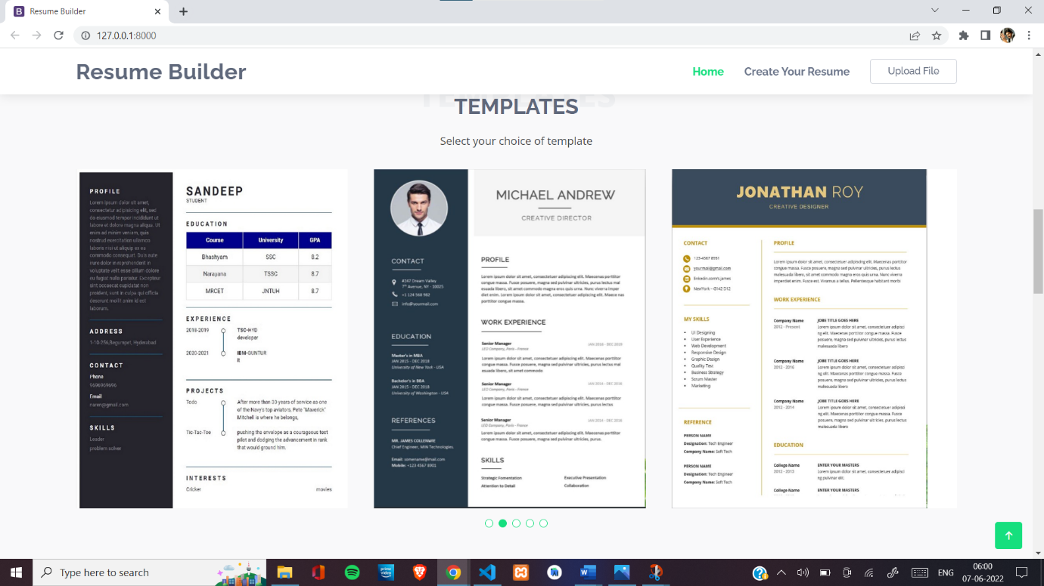

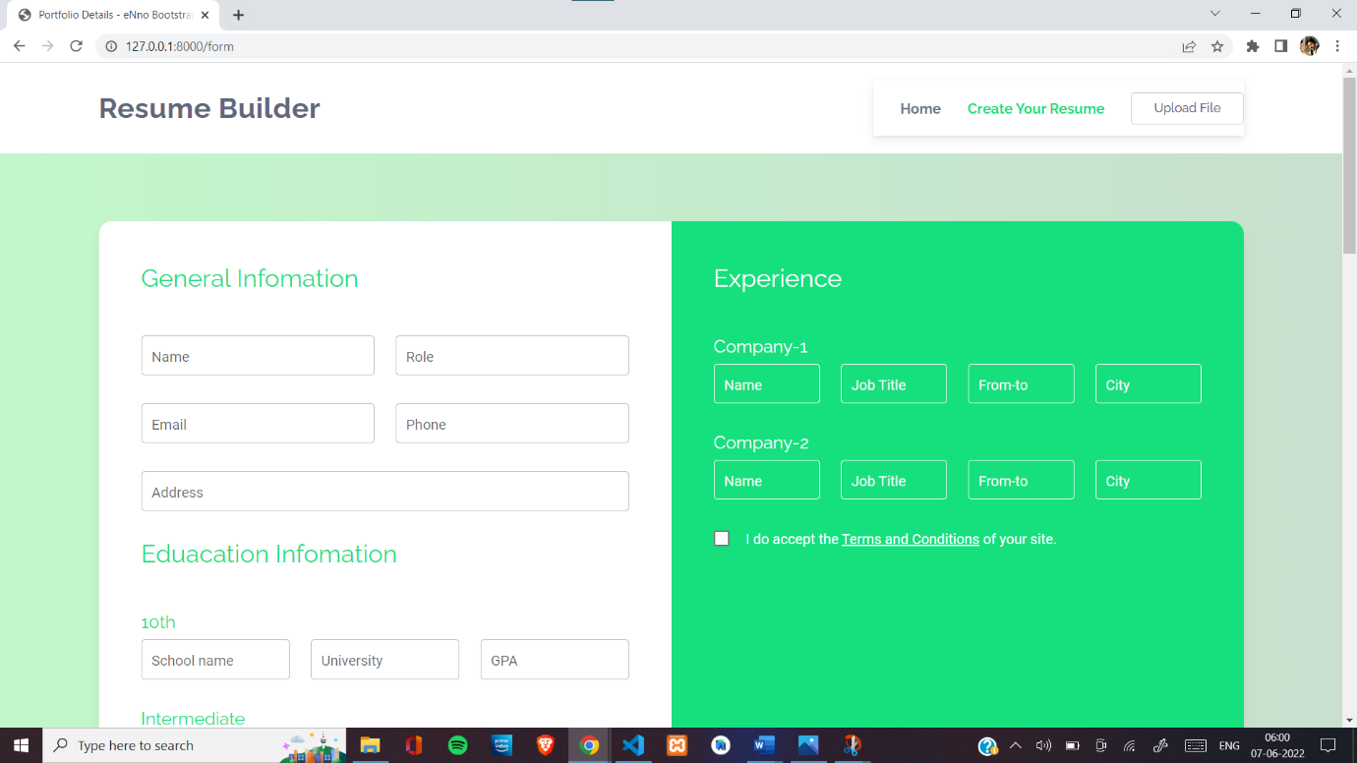
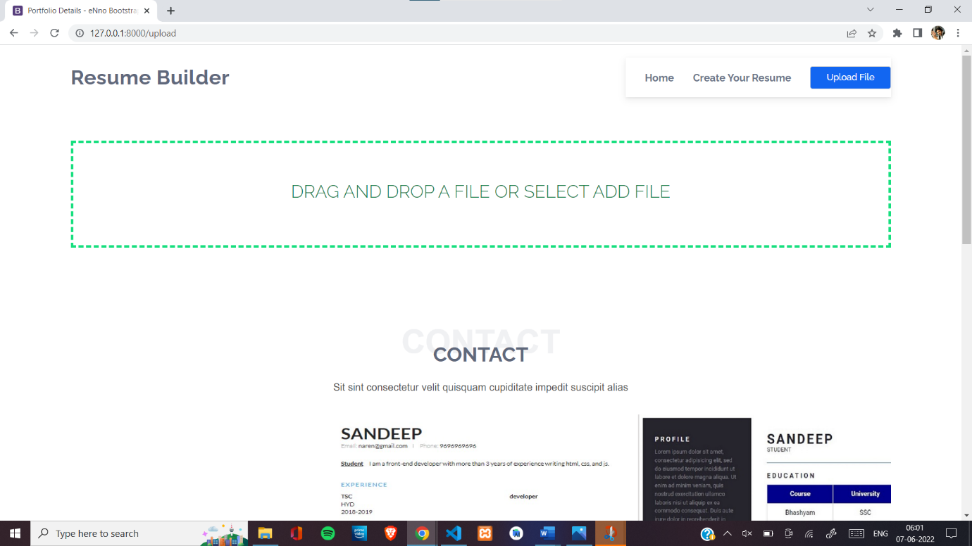
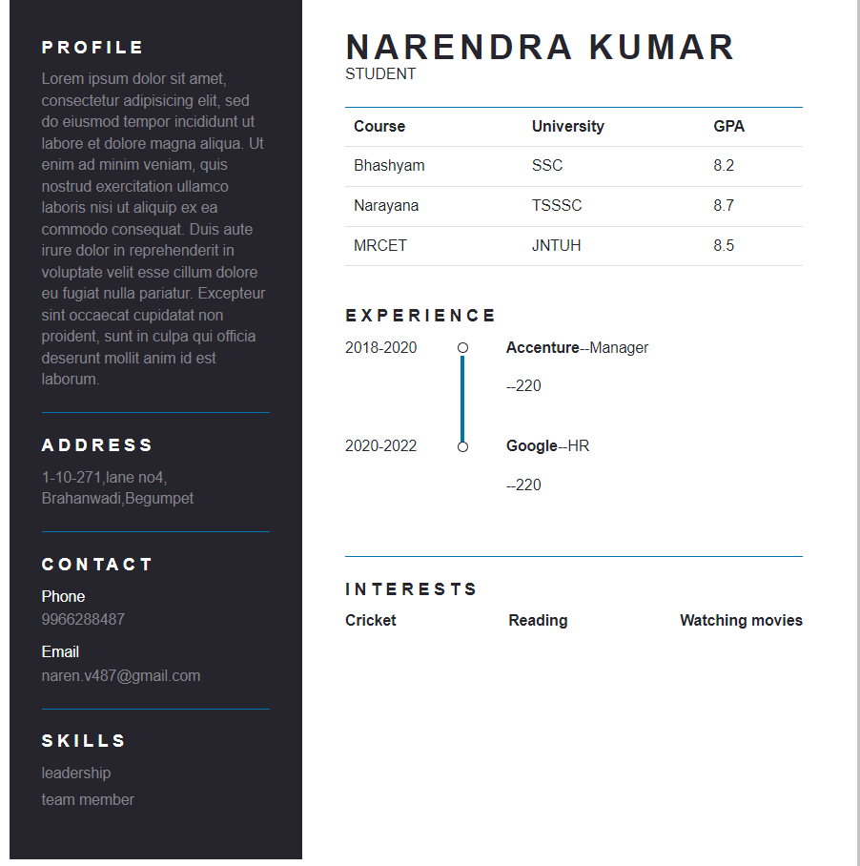
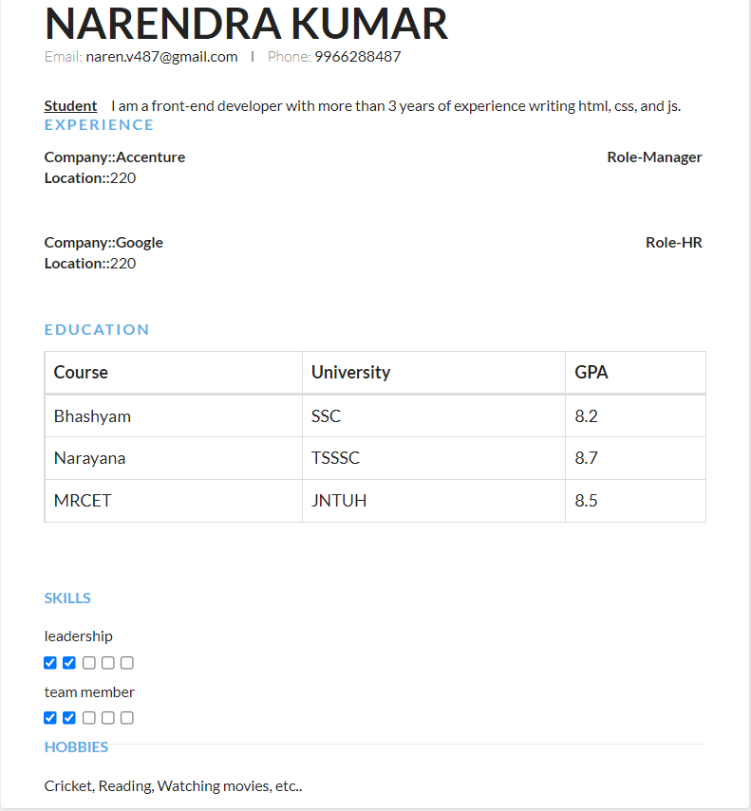

9. CONCLUSION & FUTURE SCOPE

9.1 CONCLUSION:

This project will help you through the process that can be followed to build your resume-builder using Django in python. Implementing the project will give you the satisfaction of auto-generating it on your own and helping working professionals with the same . Build a Resume-Builder Web App and add it to your resume to get recognized With additional Features like generating large ‘N’ of resumes, Which is a useful feature for a Collages or Organisations.
The project Resume Builder with Django is for computerizing theworking of building resumes. The software takes care of all therequirements of the process and is capable to provide easy andeffective storage of information related to customers andresumes that come up to the system.It generates reports for customers & administrators. Provideseasy designing tools and other interesting features. The systemalso provides the facility to contact the customer. This system provides online storage/ updates and retrievalfacility. This system promises very less or no paper work andalso provides help to customers and viewers. In this systemeverything is stored electronically so very less amount of paperwork is required and information can be retrieved very easilywithout searching here and there into registers.

9.2 FUTURE SCOPE:

In Future we will add as many as templates as possible so that user can have a wide variety of choices and we will improve the front end and back end and also to encrypt the data provided by users

10. BIBLIOGRAPHY

- "Google Code Archive - Long-term storage for Google Code Project Hosting". Retrieved 30 April 2016.
- ^ maxirobaina. "GitHub - maxirobaina/django-firebird: Firebird SQL backend for django". GitHub. Retrieved 30 April 2016.
- ^ "Django non-rel". Retrieved 30 April 2016.
- ^ beachmachine. "GitHub - beachmachine/django-jython: Database backends and extensions for Django development on top of Jython". GitHub. Retrieved 30 April 2016.
- ^ Running Pure Django Projects on Google App Engine. Code.google.com (1 November 2010). Retrieved on 5 December 2011.
- ^ "Django's release process - Django documentation - Django". Retrieved 30 April 2016.
- ^ "Download Django - Django". www.djangoproject.com.
- ^ "FAQ: Installation - Django documentation - Django". docs.djangoproject.com.
- ^ "Introducing Django 0.90". Django weblog. Retrieved 2 February 2013.
- ^ "Django 0.91 released". Django weblog. Retrieved 2 February 2013.
- ^ "Introducing Django 0.95". Django weblog. Retrieved 2 February 2013.
- ^ "Announcing Django 0.96!". Django weblog. Retrieved 2 February 2013.
- ^ "Django 1.0 released!". Django weblog. Retrieved 2 February 2013.
- ^ "Django 1.1 released". Django weblog. Retrieved 2 February 2013.
- ^ "Django 1.2 released". Django weblog. Retrieved 2 February 2013.
- ^ "Django 1.3 released". Django weblog. Retrieved 2 February 2013.
- ^ "Django 1.4 released". Django weblog. Retrieved 2 February 2013.
- ^ "Django 1.5 released" Django weblog. Retrieved 27 February 2013.
- ^ "Django 1.6 released" Django weblog. Retrieved 6 November 2013.
- ^ "Django 1.7 released" Django weblog. Retrieved 4 September 2014.
- ^ "Django 1.8 released" Django weblog. Retrieved 2 April 2015.
- ^ "Django 1.9 released" Django weblog. Retrieved 1 December 2015.
- ^ "Django 1.10 released" Django weblog. Retrieved 1 August 2016.
- ^ "Django 1.11 released" Django weblog. Retrieved 4 April 2017.
- ^ "Django 2.0 released" Django weblog. Retrieved 3 December 2017.
- ^ "Django 2.1 released" Django weblog. Retrieved 2 August 2018.
- https://docs.djangoproject.com/en/4.0/
- https://www.python.org/
- www.google.com

